**Project Overview: -**

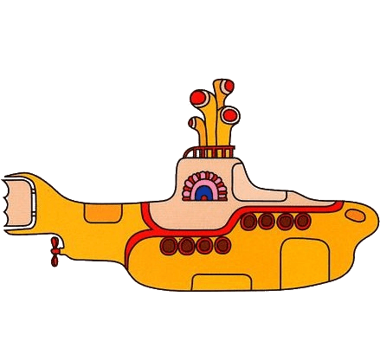When a submarine swims underwater, it detects the topography it used to throw and receive SONAR waves. So, the project is concerned about a war situation in which a submarine enters an enemy’s territory full of boulders(rocks) and mines. We have a dataset through which we have to predict whether the object detected by SONAR waves is a rock or mine.

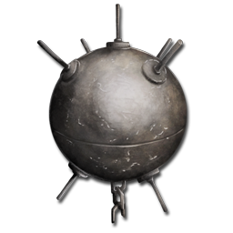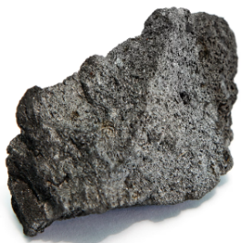

SONAR

Mine

Rock

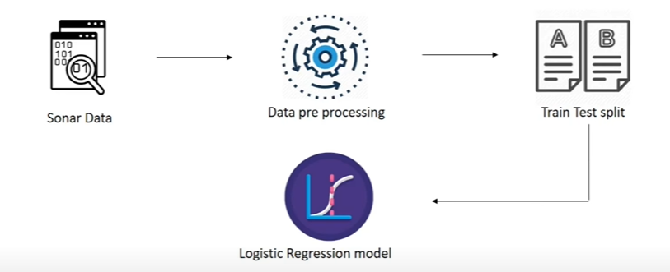**Workflow: -**

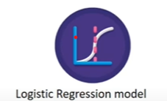

Predict Rock or Mine

New data

Predict Rock or Mine

After training results: -

We have divided the whole data into 2 parts i.e., train and test.

Train data accuracy = 83%

Test data accuracy = 76%

As amount of data are small for that reason the accuracy value is not nearing 90%. But we consider accuracy to be good as it is greater than 70%.

Code is in google drive